Coatham Surgery

Carers Information Pack

Supporting Patients and Their Carers



About Carers & Notifying Your GP

What is a Carer?
A carer is anyone providing unpaid support to a family member, friend, or neighbor who could not manage without help due to illness, disability, mental health condition, or substance misuse. The care they give is unpaid.

Let Us Know You're a Carer:
Registering as a carer with your GP surgery helps ensure both you and the person you care for receive the support you need. Benefits include:

Recognition and Record Keeping
Your status as a carer is formally recorded on your and/or the patient’s medical notes.
This ensures healthcare staff are aware of your caring responsibilities.

Health Checks and Vaccinations
You will be entitled to vaccinations such as flu and COVID. We may recognize early identification of stress, mental health concerns, and chronic conditions.

Flexible Appointment Scheduling
We can offer appointments at times that fit around your caring responsibilities and telephone consultations can be arranged.

Support and Referrals
We can make referrals to social prescribing workers who connect you to local support groups, financial advice, and respite care.
Access to Carers Assessments via local councils for practical and emotional support.

Emergency Planning
We can provide guidance on emergency care plans if you are suddenly unable to provide care and you may be issued an emergency carer card via local support organisations like Carers Together.

Improved Care for the Person You Support
Healthcare staff are aware of the person’s support network.
Helps ensure care plans are realistic and considerate of the carer’s availability and wellbeing.

Complete a carers registration form on page 5 or let a member of the team know.

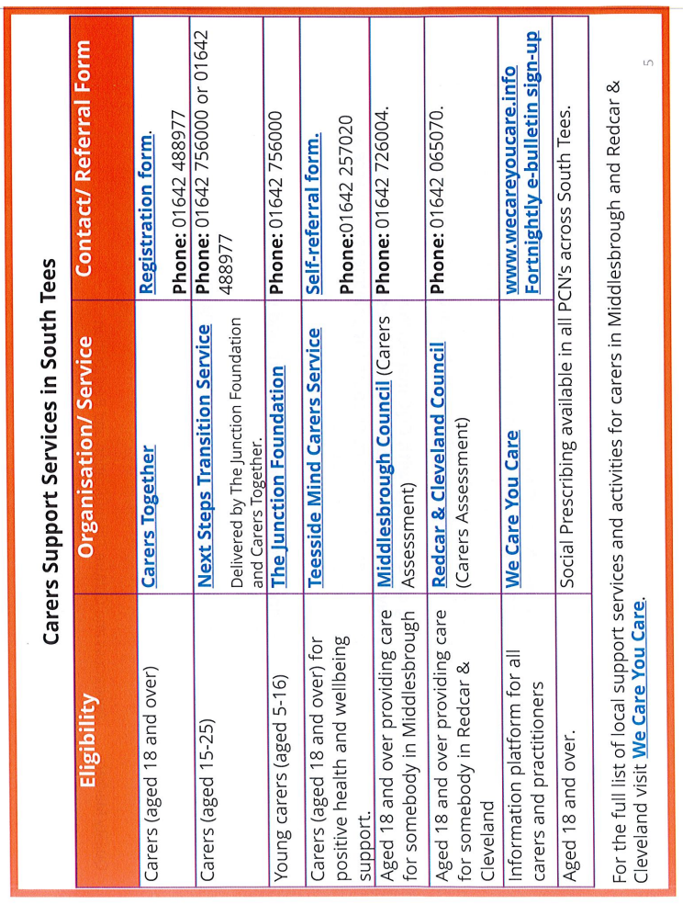

Local Support & Wellbeing

Local Support
- Carers Together – 01642 488977, www.carerstogether-rc.org.uk
- Redcar & Cleveland Council Adult Social Care – 01642 771500, Support for Carers
- Teesside Mind Carers Service – 01642 257020
- The Junction Foundation (aged 5-16 years) – 01642 756000, info@thejunctionfoundation.com
- We Care You Care – 01642 249300, www.wecareyoucare.info

Online Resources
- NHS Carers www.nhs.uk/conditions/social-care-and-support-guide/help-from-carers
- Carers UK www.carersuk.org

Social Prescribing
Ask your GP for referral to link workers who can connect you to support groups, wellbeing activities, and financial advice.

Emergency Contacts
- Emergency Duty Team (out of hours): 01642 524552
- Carers Together Emergency Card Scheme: 01642 488977

Surgery Contact:
Coatham Surgery, Coatham Road, Redcar, TS10 1SR
Phone: 01642 483638
Website: www.coathamsurgery.co.uk

